**Storage systems in Azure**

**1: Azure Blob Storage**

What is Azure Blob Storage?  
Azure Blob Storage is Microsoft’s object storage solution for the cloud, optimized for storing massive amounts of unstructured data such as images, videos, logs, and backups.

Key Features

* Three blob types: block blobs for large file uploads, append blobs for logging scenarios, and page blobs for frequent read/write workloads.
* Access tiers (hot, cool, archive) to optimize storage costs based on data access patterns.
* REST APIs and client libraries for .NET, Java, Python, JavaScript, and more for seamless integration.

Common Use Cases

* Media hosting and streaming for web and mobile applications.
* Big data analytics with Azure Data Lake Storage Gen2 and Databricks.
* Backup, disaster recovery, and long-term archiving with lifecycle management.

Best Practices

* Define lifecycle policies to transition blobs between tiers automatically.
* Secure blobs with role-based access control, shared access signatures, and encryption at rest and in transit.
* Monitor performance and costs using Azure Monitor metrics and Storage Analytics logs.

**2: Azure File Storage:**

What is Azure File Storage?  
Azure File Storage delivers fully managed, cloud-native file shares accessible via SMB 3.1.1, NFS 4.1, or REST API. It behaves like an on-premises file server, enabling lift-and-shift migrations and hybrid file scenarios.

Key Features

* Standard SMB and NFS protocol support across Windows, Linux, and macOS clients.
* Identity-based authentication via Microsoft Entra ID and on-premises Active Directory Domain Services.
* Azure File Sync to cache and sync file shares on Windows Servers for local performance and cloud backup.

Common Use Cases

* Replacing or extending on-premises file servers with cloud file shares.
* Shared configuration, diagnostic, or log file repositories for distributed applications.
* Persistent storage volumes for stateful containers in AKS or App Service.

Best Practices

* Use Azure File Sync to reduce egress costs and improve local access times.
* Apply NTFS permissions and Azure RBAC to manage access control.
* Leverage performance tiers and snapshot backup for data protection.

**3: Azure Table Storage**

What is Azure Table Storage?  
Azure Table Storage is a schemaless NoSQL key-attribute data store designed for structured, but non-relational, datasets. It offers low-cost, high-throughput storage for millions to billions of entities.

Key Features

* PartitionKey and RowKey pair forms a unique entity identifier, enabling fast lookups and horizontal scaling.
* Schemaless design that adapts easily to evolving data models without database migrations.
* Integration via OData REST API and client libraries for .NET, Java, Python, and JavaScript.

Common Use Cases

* Storing user profiles, device telemetry, or address book data in web and mobile apps.
* Metadata repository for media catalogs, IoT device logs, or configuration settings.
* Session state storage and audit logs where flexible schemas and rapid reads/writes are essential.

Best Practices

* Design PartitionKey to evenly distribute workload and avoid hot partitions.
* Query only on PartitionKey and RowKey when possible to minimize storage transactions.
* Monitor throughput targets and scale out with multiple storage accounts or Azure Cosmos DB Table API for global distribution.

**4: Azure Queue Storage**

What is Azure Queue Storage?  
Azure Queue Storage provides a reliable, highly-scalable messaging service for decoupling application components. It stores large numbers of messages (up to 64 KiB each) that can be accessed via HTTP/HTTPS and client libraries.

Key Features

* Visibility timeout and message TTL to control processing retries and message lifespan.
* Up to millions of messages per queue, with support for batch operations to improve throughput.
* SDKs for .NET, Java, Python, JavaScript, and REST API access.

Common Use Cases

* Task scheduling and background processing in web and mobile backends.
* Decoupling microservices to achieve fault isolation and load leveling.
* Distributed job orchestration for ETL pipelines, image processing, or notifications.

Best Practices

* Implement a poison message queue to handle repeatedly failing messages.
* Use message batching and long polling to reduce transaction costs and improve efficiency.
* Secure access with shared access signatures, Azure AD roles, or managed identities.

**5: Comparison Matrix:**

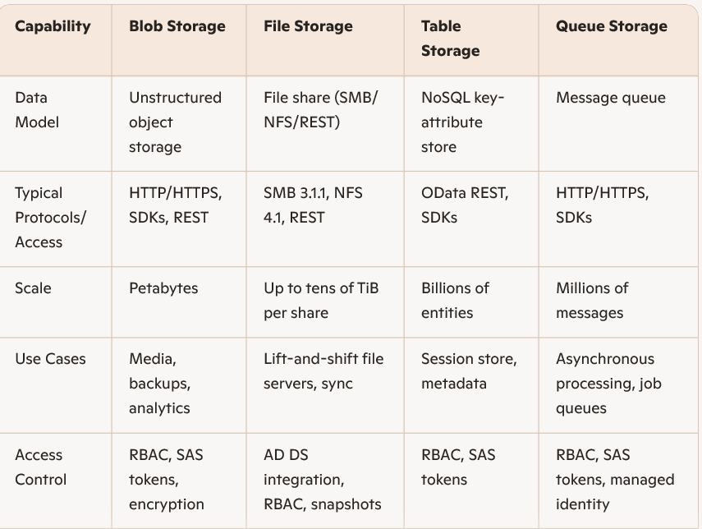

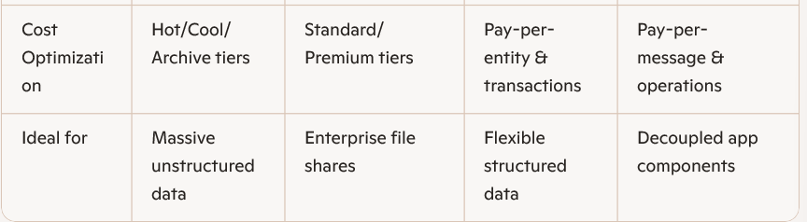

|  |  |  |  |  |
| --- | --- | --- | --- | --- |
|  |  |  |  |  |
|  |  |  |  |  |
|  |  |  |  |  |
|  |  |  |  |  |
|  |  |  |  |  |
|  |  |  |  |  |
|  |  |  |  |  |

Beyond these four core storage services, Azure offers specialized options such as Azure Disk Storage for VM disks, Azure Data Lake Storage Gen2 for big data analytics, and Azure NetApp Files for high-performance enterprise shares. You might also explore monitoring strategies with Azure Monitor, automated cost management via Azure Cost Management, and hybrid architectures using Azure Stack